

Feature Description Document (FDD)

Version 1.0

**Table of Content**

**1.0 Feature Description** **3**

1.1 Assumptions 3

1.2 In-Scope 3

1.3 Out-of-Scope 3

1.4 Future Sope 3

**2.0 Database Schema** **3**

2.1 End-to-end Flow 4

**3.0 Solution Architecture** **5**

**4.0 Deployment Strategy** **6**

4.1 Benefits 6

**4.0 Technology Stack** **6**

# **1.0 Feature Description**

Develop a web service, using resources on AWS, that accesses the database in real-time and provides excellent visualization of the time series analysis of Voltage, Current, and Power (Voltage * Current).

## 1.1 Assumptions

* AWS account shall be used by the developer.
* All the requirement is shared through the mail.

## 1.2 In-Scope

* Create voltage and current curve of the selected sensor ID.
* Create a power curve of the selected sensor ID.

## 1.3 Out-of-Scope

* Adding a new record to sensor ID.

## 1.4 Future Sope

* User Authentication.
* Role Base Access Control of the application.
* Near to real-time notification service.

# **2.0 Database Schema**

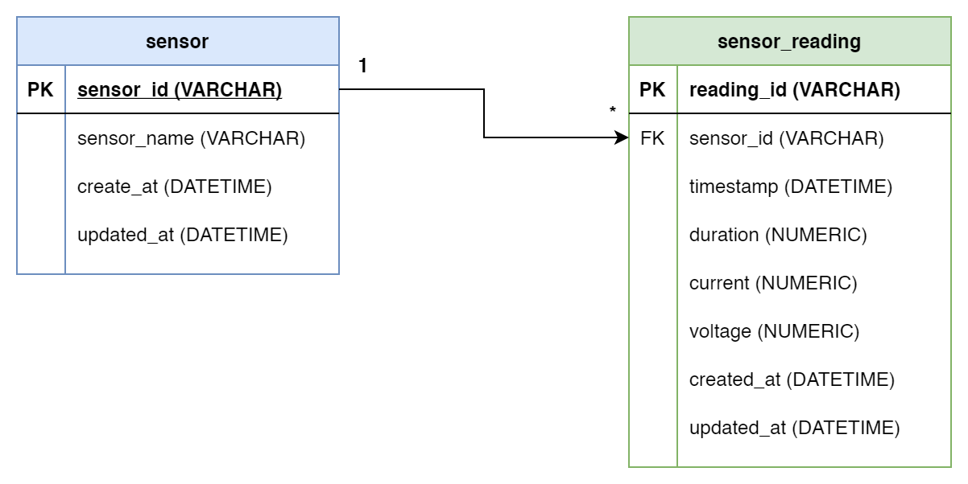

## 2.1 End-to-end Flow

The end to end flow will be following for the feature -

* We will populate the data from provided datasheet into the database using the automation scripts.
* For populating the data to the frontend, the user will first select the sensor for which the data needs to be populated.
* Backend will populate the sensor_reading data to the end-user based on the Sensor selected from UI.
* The backend server will return the sensor readings back to the frontend.

# **3.0 Solution Architecture**

# 

# **4.0 Deployment Strategy**

## 4.1 Benefits

* Scaleable
* Easy Deployment
* Cost-Efficient

# **4.0 Technology Stack**

* AWS
  + AWS Lambda
  + AWS RDS
  + AWS API gateway
  + AWS S3
* Python 3.x
* Serverless Framework
* UI
  + HTML, CSS and Javascript